Summer 2026 AI687 AI Capstone Final Report
Evaluating Hallucination Risk in AI-Generated Polysomnography Reports Under Controlled Artifact Contamination

Svetlana Grabar
Advisor: Taejin Kim
MS in Artificial Intelligence (MSAI)
School of Technology & Computing (STC)
City University of Seattle (CityU)
grabarsvetlana@cityuniversity.edu, kimtaejin@cityu.edu

Abstract
This study investigated how artifacts in polysomnography recordings influenced the likelihood of hallucinations, or fabricated findings, in AI-generated reports. Artifacts like patient movement, muscle activity, and poor electrode contact are common in real-world recordings and can interfere with accurate interpretation. Recent advances in sleep-language models such as SleepLM have made it possible to generate reports directly from polysomnography recordings, but the impact of artifacts on these reports remains poorly understood. Using SleepLM, this study generated reports from both original polysomnography recordings and those containing simulated artifacts of varying types and severity levels. Each AI-generated report was compared with expert-annotated reference data using an LLM-as-a-judge framework to identify hallucinations. These evaluations were then used to assess how different artifact types and severity levels influenced the reliability of AI-generated reports. The results showed that hallucination rates stayed largely consistent across artifact conditions, regardless of type or severity, and none of the differences reached statistical significance. Hallucination occurrence varied more across sleep stages, suggesting that sleep stage was more closely associated with hallucinations than the injected artifacts. The framework developed in this study can serve as a template for future evaluations of how different clinical AI models respond to real-world signal artifacts and when those artifacts begin to affect generated reports.

Keywords: Hallucination detection, Polysomnography, Signal artifact injection, Explainable AI

- INTRODUCTION
Polysomnography (PSG) is widely used to diagnose sleep disorders by recording multiple physiological signals throughout the night. Traditionally, these recordings are manually reviewed by trained sleep technologists, a time-consuming process with variable reliability between reviewers (Lee et al., 2022). Recent advances in artificial intelligence have created opportunities to automate PSG analysis, progressing from automated sleep staging toward models capable of generating natural-language sleep reports directly from physiological signals (Xu et al., 2026).

PSG recordings are also prone to physiological and technical artifacts, arising from factors such as patient movement, muscle activity, electrical interference, and poor electrode contact (Anandanadarajah et al., 2024). These artifacts have been shown to degrade deep learning model performance, and prior work has developed methods for detecting or removing them (Duggal et al., 2020; Zhang et al., 2021). At the same time, hallucinations, or unsupported and fabricated findings, have emerged as a major concern for generative AI in clinical settings (Asgari et al., 2025). However, little research has examined whether and how specific PSG artifacts increase hallucination risk in AI-generated reports, leaving the relationship between signal artifacts and hallucination risk largely uncharacterized.

This study investigated how physiological PSG artifact type and severity influenced hallucination risk in AI-generated sleep reports. Controlled artifacts at varying severity levels were introduced into PSG signals, which were then used to generate natural-language sleep reports. The generated reports were evaluated for hallucinations against expert-annotated reference data to identify how hallucination risk varied across artifact types and severity levels. Beyond its findings for PSG, this research provided a framework for evaluating hallucination risk under realistic signal degradation in other areas where AI-generated clinical interpretation is emerging.

Problem Statement
As AI systems begin to generate PSG reports directly from raw signal data (Xu et al., 2026), it remains unclear how physiological signal artifacts affect the likelihood of hallucinations, or fabricated findings, in generated reports. These artifacts are common in real-world recordings, arising from routine issues like patient movement, muscle tension, or poor electrode contact (Anandanadarajah et al., 2024). Although existing studies have evaluated AI robustness to synthetic noise and broad classes of signal degradation, they have not systematically investigated how specific physiological artifact types and their severity levels influence hallucination risk in AI-generated PSG reports.

Without knowing how specific artifact types and severities relate to hallucination risk, it is difficult to determine when an automated report is reliable. Addressing this requires moving beyond general robustness testing toward a more granular understanding of how individual physiological artifact types, in isolation and across severity levels, influence the reliability of automated sleep report generation.

Motivation
Although recent sleep-language models have demonstrated the ability to generate natural-language interpretations directly from PSG recordings (Xu et al., 2026), their behavior under clinically realistic signal artifacts remains largely uncharacterized. SleepLM, one of the first foundation models designed for this task (Xu et al., 2026), is described by its developers as a research prototype rather than a validated clinical decision-support tool. Deep learning models for sleep staging have shown substantial performance degradation under increasing levels of synthetic EEG noise (Duggal et al., 2020). However, reduced signal quality may affect not only predictive accuracy but also the likelihood that generative AI models produce hallucinations. Understanding this relationship could support future artifact-aware quality assessment, confidence estimation, and safeguards for identifying reports that require clinician review.

Approach
Controlled artifacts that are commonly seen in the real world were injected into an EEG channel from the St. Vincent’s University Hospital/University College Dublin Sleep Apnea Database (St. Vincent’s University Hospital/University College Dublin Sleep Apnea Database, 2007) at two severity levels. These artifact-injected signals were then passed to SleepLM to generate natural-language sleep reports. Each generated report was compared and evaluated for hallucinations with expert-annotated reference reports using an LLM-as-a-judge framework. The evaluation produced hallucination labels associated with each artifact type and severity level, enabling analysis of how specific artifact characteristics influenced hallucination risk in AI-generated PSG reports.

Conclusions
This study aimed to provide a systematic characterization of how specific PSG artifact types and severity levels affected hallucination risk in AI-generated sleep reports. By linking artifact characteristics to hallucination outcomes, this work moved beyond general robustness testing toward artifact-specific risk profiles that could inform when an automated report warranted clinician review. Beyond its immediate findings, this approach offered a template for evaluating hallucination risk under realistic signal degradation in other physiological domains where AI-generated interpretation is emerging. Ultimately, this work aimed to support the safe and reliable integration of AI-assisted interpretation into clinical sleep medicine.

2. BACKGROUND

Polysomnography is the standard test used to diagnose sleep disorders. Standard PSG records multiple physiological signals, including EEG, electrocardiography (ECG), electrooculography (EOG), and recordings of airflow, respiratory effort, oxygen saturation, and limb electromyography (EMG) (Yin et al., 2023). These physiological signals are recorded continuously during a PSG throughout sleep to evaluate sleep architecture and identify abnormalities associated with sleep disorders (Rundo & Downey, 2019). PSG is used for diagnosing sleep disorders such as sleep apnea, nocturnal seizures, narcolepsy, periodic limb movement disorder, and rapid eye movement sleep behavior disorder (Rundo & Downey, 2019).

Traditionally, whole-night PSG recordings are divided into 30-second epochs and then are manually reviewed by trained sleep technologists before physician interpretation. Manual scoring is a time-consuming process that can require 2-4 hours and exhibits variable scorer reliability ranging from 61.1% to 92.2%. Currently, automated systems using artificial intelligence are being developed, but manual scoring is still the gold standard because automated systems have not yet demonstrated sufficient reliability for clinical use (Lee et al., 2022).

Recent advances in deep learning have expanded AI applications beyond automated sleep staging to include models capable of generating natural-language interpretations directly from PSG recordings (Xu et al., 2026). While these systems are intended to reduce the need for manual interpretation, they also introduce the possibility of hallucinations, in which generated reports contain unsupported or fabricated findings (Huang et al., 2025). Hallucinations are of particular concern in clinical settings because fabricated findings may lead to inaccurate or misleading diagnostic information (Asgari et al., 2025).

The reliability of AI-generated sleep reports may be further affected by artifacts present in physiological PSG signals. Artifacts can distort or obscure physiological information and are common in real-world recordings (Yin et al., 2023). Existing research has separately investigated AI-based PSG interpretation, physiological signal artifacts and denoising, and methods for evaluating hallucinations in AI-generated medical reports. However, limited research has examined the relationship between physiological PSG artifacts and hallucination risk in AI-generated sleep reports. In particular, the effects of different artifact types and severity levels on the factual reliability of generated reports remain insufficiently understood. Investigating this relationship is therefore important for determining the reliability and safety of AI-assisted PSG interpretation and for understanding the conditions under which physiological signal quality may contribute to hallucinations.

3. RELATED WORK

Recent advances in large language models have enabled applications in sleep medicine (Xu et al., 2026), increasing the need to evaluate the reliability of AI-generated clinical reports (Asgari et al., 2025). This literature review covers prior work on hallucinations in medical AI, LLM-based evaluation, sleep-language models, physiological signal analysis, and physiological artifacts to provide context for this study.

Literature Review
Hallucinations in large language models (LLMs) have become an active area of research, especially in healthcare where incorrect information may affect clinical decisions. Huang et al. (2025) offered a formal definition that splits hallucinations into two types: statements that directly contradict the source material, and statements that cannot be checked against it at all. The study also reviewed common causes of hallucinations, methods of detecting them, and current approaches for reducing them. Hallucinations often stem from fake news, societal biases, outdated knowledge, lack of context, and inability to express uncertainty. Detection methods include fact-checking and uncertainty estimation. This research creates a shared vocabulary and produces a useful framework for future studies. Asgari et al. (2025) applied these ideas to AI-generated clinical documentation and found that some hallucinations were serious enough to influence patient diagnosis and management. These findings show that in medical applications, hallucinations represent a safety concern. These studies provide both the definition of hallucination used in this project and the motivation for studying hallucinations in AI-generated PSG reports.

The next challenge is evaluating AI-generated text at scale, since human review is slow and expensive. Gu et al. (2026) surveyed the LLM-as-a-judge approach, in which an LLM grades other AI outputs instead of relying on people or simple text overlap metrics. The study showed how these systems work and documented known problems, such as the judge favoring longer answers. Ostmeier et al. (2024) used LLM-as-a-judge in radiology reports with their GREEN method. It compared a generated report with a ground-truth reference report, flagged clinically meaningful errors, and produced a score and an explanation. When tested on which of two reports a radiologist preferred, GREEN reached 68% accuracy. This substantially outperformed asking GPT-4 to state a preference directly (23%) but still fell short of the 81% agreement radiologists showed each other. Lee et al. (2022) further demonstrated that even human experts do not perfectly agree when interpreting PSG recordings. While overall agreement was substantial, some sleep stages showed much lower consistency, highlighting the difficulty of establishing a perfect ground truth. While these studies demonstrated that LLM-as-a-judge can effectively evaluate clinical reports, they also showed that the approach is imperfect.

Xu et al. (2026) introduced SleepLM, a system that generates natural-language reports from polysomnograms rather than simply labeling recordings with predefined categories such as “N2” or “apnea”. The dataset consisted of over 100,000 hours of PSG data from more than 10,000 individuals. Across multiple evaluations, SleepLM substantially outperformed both Gemini 2.5 Pro and DeepSeek-R1. For sleep stage classification, SleepLM achieved a balanced accuracy of 76.9%, compared with 52.2% for Gemini 2.5 Pro and 50.9% for DeepSeek-R1. It also achieved a sleep event localization IoU of 30.4%, compared with 2.8% for Gemini 2.5 Pro and 1.6% for DeepSeek-R1. Despite these promising results, the authors note that SleepLM remains a research prototype and has not been clinically validated for diagnosis, treatment, or medical decision-making.

Gaiduk et al. (2023) reviewed the physiological signals used in sleep analysis and explained the distinct roles of EEG, EOG, EMG, ECG, and other signals in identifying sleep stages and events. Their analysis of 125 articles on automatic sleep stage scoring found that the EEG signal is the most widely used, with 69 publications relying on it alone. They also identified explainability and usability as persistent weaknesses in the field. Lee et al. (2025) proposed SynthSleepNet, a multimodal model that combines EEG, EOG, EMG, and ECG rather than relying on a single channel. It outperformed prior state-of-the-art methods on three downstream tasks, reaching 89.89% accuracy on sleep stage classification, 99.75% on apnea detection, and 89.60% on hypopnea detection.

Physiological artifacts present another important challenge for polysomnography. Ujma et al. (2025) compared manual and automated artifact detection in sleep EEG recordings and found that a relatively small number of extreme artifacts accounted for most signal distortion, particularly in the beta, gamma, and NREM delta frequency bands. Anandanadarajah et al. (2024) further demonstrated that movement artifacts, lead-popping, electrical interference, and other forms of signal contamination remain common in clinical PSG recordings and that even experienced sleep technicians do not always identify them consistently. To support controlled experimentation, Zhang et al. (2021) introduced EEGdenoiseNet, which generates realistic ocular and muscular artifacts by combining original EEG recordings with recorded EOG and EMG artifact segments. The authors note that physiological artifacts contaminate EEG signals, making denoising or artifact attenuation a fundamental step in EEG analysis. A key limitation is that the dataset contains only ocular (EOG) and myogenic (EMG) artifacts and does not include common PSG artifacts such as electrode pops or movement artifacts. Although EEGdenoiseNet was developed to benchmark deep learning-based denoising methods, its realistic artifact generation framework provides a useful foundation for studying how different artifact types affect the reliability of AI-generated sleep reports. Similarly, Agounad et al. (2022) generated synthetic EEG recordings containing multiple artifact types with varying amplitudes and durations, further demonstrating the feasibility of controlled artifact injection for evaluating AI systems. These studies demonstrate that artifacts are both a common challenge in polysomnography and feasible to simulate under controlled experimental conditions.

Review Conclusions
Taken together, this literature establishes both why hallucinations in AI-generated clinical text matter and how they can be studied. Huang et al. (2025) and Asgari et al. (2025) show that hallucinations are not just a technical flaw but a patient safety concern. Gu et al. (2026) and Ostmeier et al. (2024) show that LLM-as-a-judge offers a scalable way to detect these errors, even though it does not yet fully match expert judgment. Lee et al. (2022) add an important caveat here: even human experts disagree with each other when scoring sleep data, so no evaluation method, automated or manual, should be expected to align perfectly with a single ground truth. These studies motivate this project's approach to use an LLM judge to flag hallucinations in AI-generated PSG reports while recognizing the limitations of its evaluations.

The remaining studies focus on the practical design of this project. Given its strong performance, SleepLM was selected to generate the PSG reports evaluated in this study. It is also important to make sure that any simulated artifacts are realistic enough to produce meaningful results. Gaiduk et al. (2023) and Lee et al. (2025) help determine which physiological signals to prioritize when injecting artifacts. EEG dominates current sleep-staging methods, but multimodal combinations like SynthSleepNet improve performance across multiple tasks. These findings support examining artifacts originating from different physiological sources rather than focusing on a single artifact type.

The final set of studies shapes how artifacts are simulated and why doing so is worthwhile in the first place. Ujma et al. (2025) and Anandanadarajah et al. (2024) confirm that artifacts are common in real PSG recordings and are not always identified consistently, even by experienced technicians. This justifies studying how artifacts affect downstream AI-generated reports rather than assuming clean signal quality. Zhang et al. (2021) and Agounad et al. (2022) then provide concrete methods for simulating these artifacts under controlled conditions, injecting known artifact types at varying amplitude and duration into the original recordings. These methods provide a practical foundation for the artifact injection approach used in this project.

Figure 1
Comparison of Existing Approaches Relevant to AI-Generated PSG Report Reliability
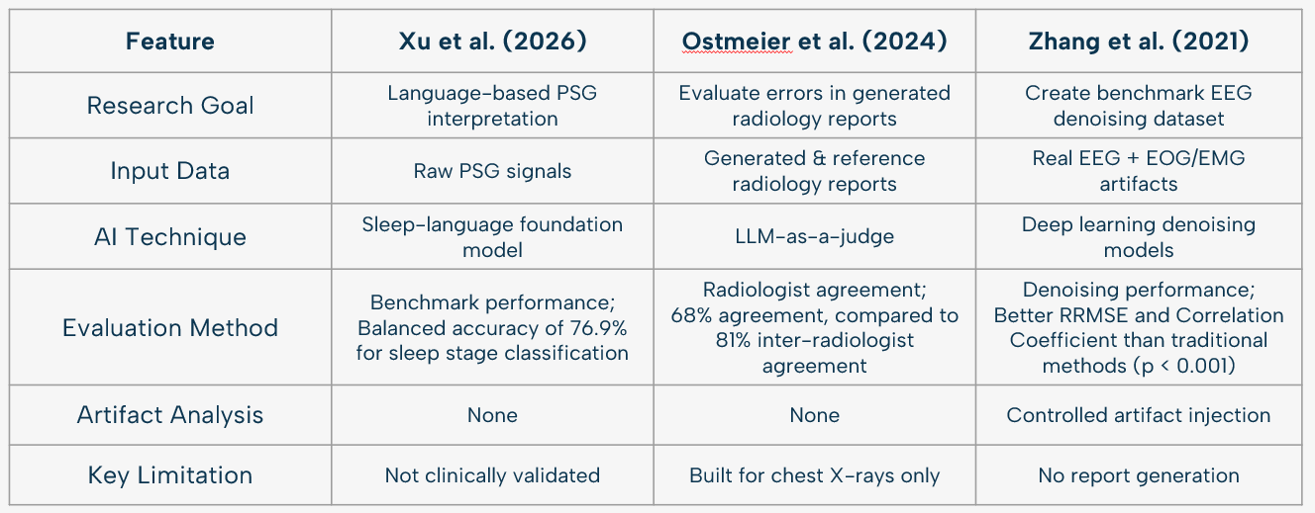

4. APPROACH

This study evaluated how PSG artifact type and severity affected hallucination risk in AI-generated sleep reports. The approach had three stages. First, controlled artifacts were injected into original PSG recordings at defined severity levels, producing paired original and artifact-injected recordings. Then, each recording was passed through SleepLM to generate a natural-language sleep report. After that, each generated report was compared against expert-annotated reference reports using an LLM-as-a-judge framework to produce hallucination labels. The result was a labeled dataset linking artifact type and severity to hallucination outcomes. This was then analyzed to identify artifact-specific risk patterns.

Design
The pipeline consisted of an artifact injection module, a report generation module, and an evaluation module. The artifact injection module introduced ocular, muscle, and cardiac artifacts into the original PSG recordings. The artifacts were introduced at two different severity levels to evaluate how artifact type and severity affected the generated sleep reports.

Each version of a recording, original and artifact-injected, was passed independently through SleepLM to generate a natural-language sleep report, producing a set of paired reports for every recording. Each generated report was then passed to the evaluation module along with the expert-annotated reference report for that recording. The evaluation module used an LLM-as-a-judge to compare the generated report against the reference and produce a binary hallucination label as the primary outcome. Secondary outcomes included the predicted sleep stage and separate labels for sleep-stage and respiratory hallucinations. Respiratory hallucinations were further classified as errors involving event presence, event type, event count, or another respiratory claim. Omissions and claims outside the scope of the available annotations were recorded separately. These labels were then used to analyze how artifact type and severity related to hallucination risk.

Figure 2
Pipeline for Evaluating the Effect of PSG Artifact Type and Severity on Hallucination Risk in AI-Generated Sleep Reports
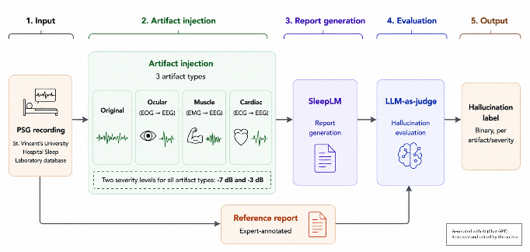

Implementation
Python 3.11.9 and MNE-Python 1.12.1 (Gramfort et al., 2013) were used to load and process the PSG recordings. The selected 30-second epochs described in the Data Collection section were extracted while retaining the physiological channels required for artifact injection and SleepLM processing.
Artifact injection was implemented using custom Python code based on the linear mixing approach described by Zhang et al. (2021). Ocular, muscle, and cardiac artifact templates were obtained from the corresponding EOG, chin EMG, and ECG channels. Each artifact template was two seconds long. Each artifact was introduced 10 seconds into the epoch and added to the C3A2 EEG channel. Ocular templates were baseline-corrected using the mean of the first 20 samples, while muscle and cardiac templates were centered by subtracting their mean.
Artifact amplitude was scaled to target signal-to-noise ratio (SNR) levels of −3 dB and −7 dB. Following Zhang et al. (2021), contaminated EEG was generated using:
y = x + λn
where y is the contaminated EEG, x is the original EEG, n is the artifact signal, and λ is the artifact scaling factor. The scaling factor was calculated using:
SNR(dB) = 20 × log₁₀[RMS(x) / RMS(λn)]

This scaling procedure was used for all three artifact types. The unmodified PSG epoch was also kept as the control condition.

Figure 3
Example of Ocular Artifact Injection into an EEG Epoch at −3 dB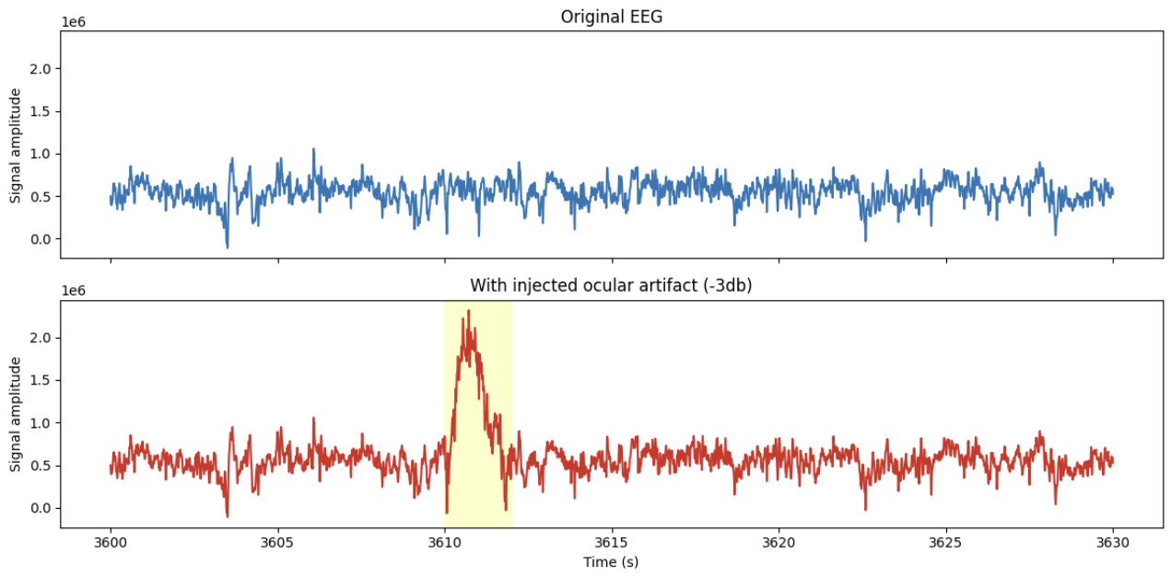
Note. The ocular artifact was injected into the C3A2 EEG channel for two seconds, beginning 10 seconds into the 30-second epoch. The visualization was created by the author using data from the St. Vincent’s University Hospital/University College Dublin Sleep Apnea Database (2007).
After artifact injection, each epoch was prepared for SleepLM using the model's required 10-channel input format. Each 30-second epoch was resampled to 64 Hz, producing 1,920 samples per channel. The nine physiological channels were independently standardized using z-score normalization, and body position was assigned −1 for unknown or other position. The resulting data were converted to a float32 tensor with dimensions of 1 × 10 × 1920.
Sleep report generation used the SleepLM-Base checkpoint (Xu et al., 2026), obtained from the model’s Hugging Face repository at commit ec0f94f. Each original and artifact-injected epoch was processed independently to generate several natural-language descriptions. Only the description containing sleep-stage and respiratory-event information was retained for hallucination evaluation.
Each generated description was compared with the expert-annotated sleep stage and respiratory events using OpenAI’s gpt-5.6-terra, guided by a written evaluation prompt and rubric developed for this study. The evaluation was blinded because the model was not provided with the experimental condition, artifact type, severity, or subject identity. The judge evaluated sleep-stage claims and respiratory claims involving event presence, absence, type, and explicit count. Respiratory timing and duration were excluded because no clinically supported error tolerance was established. The structured evaluation was converted into a binary hallucination label, while omissions and claims that could not be evaluated from the available annotations were recorded separately.
Statistical analysis was conducted in Python using pandas and SciPy. Hallucination rates were calculated as the percentage of reports containing a hallucination in each condition. Because every artifact-injected report had a matching original report from the same epoch, exact McNemar tests were used to compare these paired outcomes. The resulting significance values were adjusted using the Holm method to account for multiple comparisons. The frequencies of sleep-stage and respiratory hallucination categories were also summarized to identify the most common types.
5. DATA COLLECTION
Data for this study were obtained from the St. Vincent’s University Hospital/University College Dublin Sleep Apnea Database. This database contains 25 full overnight polysomnography recordings from adults with suspected sleep-disordered breathing. The physiological signals for each subject are stored in .rec files that use the European Data Format (EDF). Expert sleep-stage and respiratory-event annotations are stored in _stage.txt and _respevt.txt files, respectively. The subjects were referred to the Sleep Disorders Clinic at St. Vincent’s University Hospital in Dublin for possible obstructive sleep apnea, central sleep apnea, or primary snoring. The dataset includes 21 male and 4 female subjects between 28 and 68 years of age (St. Vincent’s University Hospital/University College Dublin Sleep Apnea Database, 2007).
All 25 subjects in the database were included in this study. Using a NumPy random number generator initialized with seed 42, ten unique epoch positions were selected without replacement from the positions available as complete 30-second epochs in every recording. These same positions were used for all 25 subjects, resulting in 250 original PSG epochs. Any incomplete epoch at the end of a recording was excluded from the selection pool.
Controlled artifact-injected versions of the selected epochs were then generated. MNE-Python was used to load the physiological recordings, while custom Python code was used to extract, scale, and inject artifact templates from the EOG, chin EMG, and ECG signals. Ocular, muscle, and cardiac artifacts were introduced at two predefined severity levels, −3 dB and −7 dB. This produced a controlled dataset containing both original and artifact-injected versions of the same PSG epochs.
6. DATA ANALYSIS

The analysis evaluated whether simulated physiological artifacts affected the reliability of SleepLM-generated reports. Report reliability was operationalized using a binary hallucination indicator, where a report is classified as unreliable if it contains at least one confirmed hallucination. The evaluation included seven conditions: clean PSG epochs and epochs containing EOG, EMG, or ECG artifacts at −3 dB or −7 dB. The main outcome was a binary label indicating whether each report contained at least one confirmed hallucination. Additional secondary labels identified sleep-stage and respiratory hallucinations, with respiratory hallucinations further categorized as errors involving event presence, type, count, or another unsupported claim.

The 1,750 LLM judgments, one for each generated report, were imported into a pandas DataFrame. Each artifact-injected report was paired with the corresponding clean report from the same subject and PSG epoch, making the subject–epoch the matched unit of analysis. The hallucination rate was calculated as the percentage of reports containing a hallucination in each condition. Each artifact condition was also compared with the clean condition by calculating the difference between their rates in percentage points. Sleep-stage and respiratory hallucinations were counted separately to summarize the types of errors identified by the judge. Omissions and out-of-scope claims were recorded separately and were not included in the hallucination rate.

Statistical comparisons were performed using SciPy. Exact McNemar tests were used because the clean and artifact-injected reports were generated from the same PSG epochs and therefore produced paired outcomes. For each artifact condition, the test compared how often an artifact introduced a hallucination with how often it removed one. The six resulting p-values were adjusted using the Holm method to control the family-wise error rate across the six paired comparisons. The analysis therefore produced hallucination rates, differences between conditions, paired statistical comparisons, and counts of hallucination types.

Table 1
Hallucination Outcomes by Artifact Condition
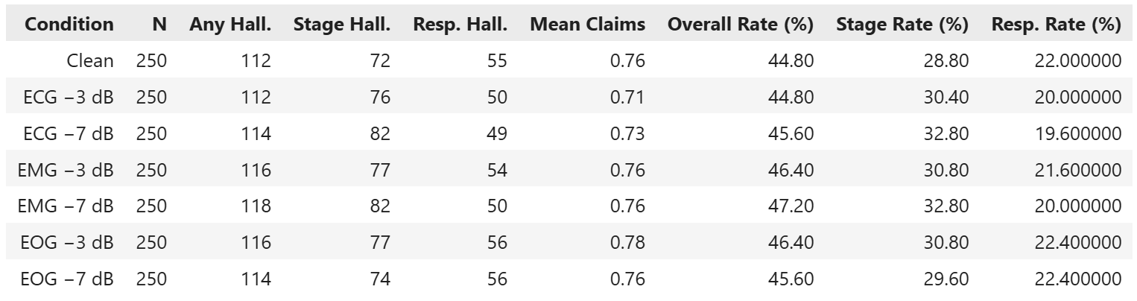

Table 2
Hallucination Rates and Paired McNemar Test Results with Holm-Adjusted p-Values
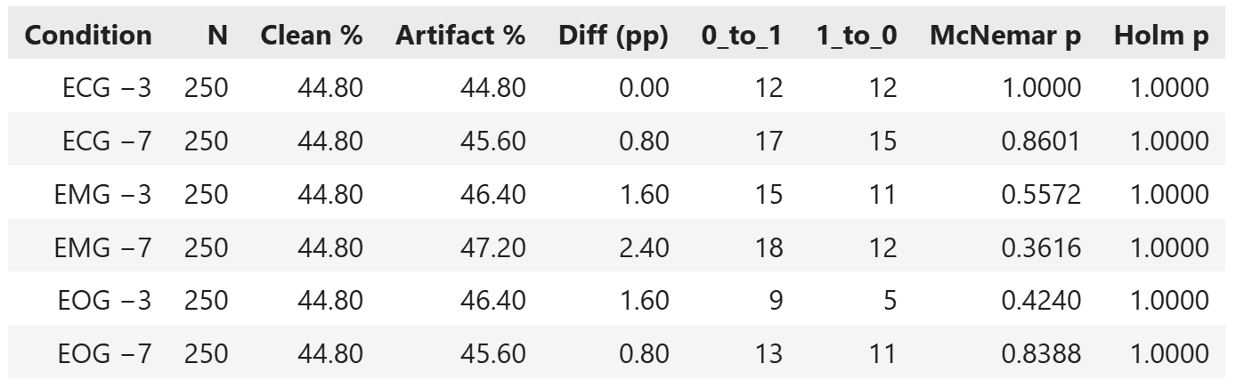
Figure 4
Row-Normalized Sleep-Stage Confusion Matrix
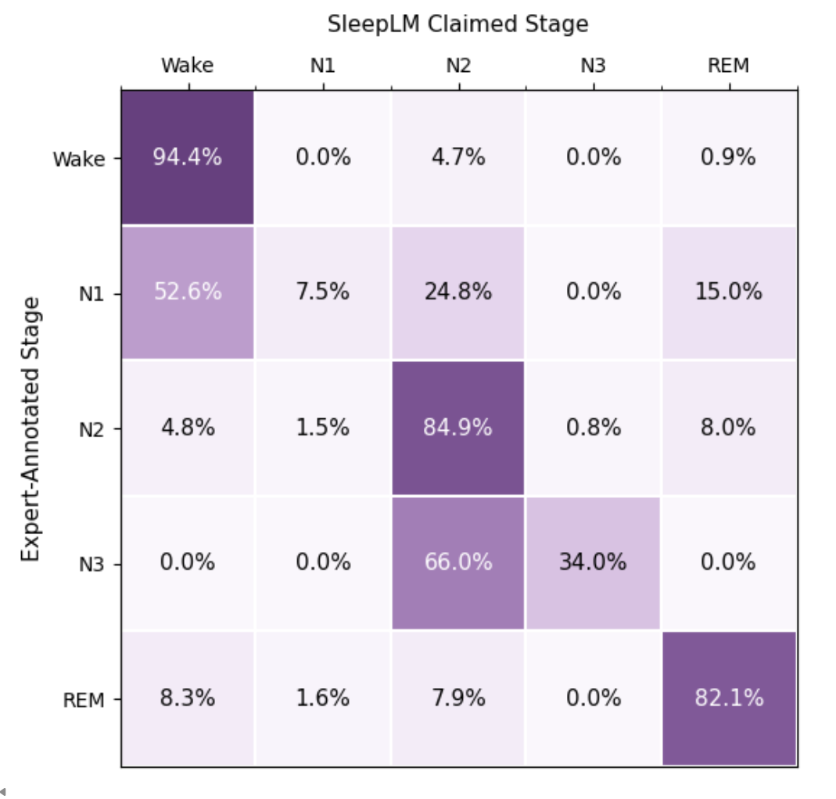

7. FINDINGS

Across the 1,750 generated reports, overall hallucination rates remained similar between the clean condition and all six artifact conditions. The clean condition had an overall hallucination rate of 44.80%, while artifact conditions ranged from 44.80% to 47.20%, with the highest rate occurring under EMG −7 dB. Stage hallucination rates ranged from 28.80% to 32.80%, and respiratory hallucination rates ranged from 19.60% to 22.40%. Paired exact McNemar tests found no significant differences in overall hallucination occurrence between the clean condition and any artifact condition, with all Holm-adjusted p-values equal to 1.000. Hallucination rates varied substantially across expert-annotated sleep stages. Overall hallucinations occurred in 95.11% of N1 reports and 66.50% of N3 reports, compared with 40.87% of REM, 32.32% of Wake, and 28.74% of N2 reports. Stage hallucinations accounted for most hallucinations in N1 and N3, occurring in 92.48% and 66.01% of reports, respectively.
These findings indicated that the addition of ECG, EMG, and EOG artifacts at −3 dB and −7 dB did not significantly increase SleepLM’s likelihood of producing hallucinated claims. Although the highest overall hallucination rate occurred under EMG −7 dB contamination, its 47.20% rate represented only a 2.40 percentage-point increase over the 44.80% clean condition and was not statistically significant. As a secondary descriptive finding, hallucination rates also differed across expert-annotated sleep stages, with the highest rates occurring in N1 and N3. SleepLM showed substantial difficulty with N1 and N3, but the error patterns differed between the two stages. N1 reports were most frequently identified as Wake or N2, whereas N3 errors were consistently identified as N2. Overall, these results did not support the hypothesis that stronger ECG, EMG, and EOG contamination would increase hallucination rates in generated sleep reports.
8. CONCLUSION
This study found that artifact type and severity did not significantly affect hallucination rates in AI-generated PSG reports. Hallucination rates remained similar across the clean and six artifact conditions, ranging from 44.80% to 47.20%, with no significant differences between any artifact condition and clean (all Holm-adjusted p = 1.000). These findings did not support the hypothesis that stronger EOG, EMG, or ECG contamination would increase hallucination rates.
Instead, sleep stage appeared to be more closely associated with hallucinations. Hallucinations occurred in 95.11% of N1 reports and 66.50% of N3 reports, compared with 28.74% to 40.87% across N2, Wake, and REM reports. The 44.80% hallucination rate in clean recordings further shows that hallucinations occurred frequently even without added contamination. Overall, these findings point to the model's interpretation of sleep stages as being more closely associated with hallucinations than the controlled artifact contamination examined in this study. The framework developed here, linking controlled signal manipulation to hallucination evaluation, offers a template that could extend to other physiological domains where AI-generated interpretation is emerging.
9. FUTURE WORK
Future studies could examine a wider range of artifacts and injection conditions. The present study evaluated EOG, EMG, and ECG contamination at two severity levels, injected into a single EEG channel. Since these conditions did not significantly affect hallucination rates, other artifact types could be tested, including movement, electrode pops, electrical interference, and baseline drift, as well as combinations of multiple artifacts. The limited range of artifact durations and severities also leaves open the possibility that stronger or longer contamination could affect report reliability. Testing longer and more variable artifact segments could help identify whether such a threshold exists. This direction is supported by Anandanadarajah et al. (2024), who identified movement and lead-popping artifacts as common sources of PSG contamination, and Ujma et al. (2025), who found that a small number of extreme artifacts may account for a substantial amount of signal distortion.
The results are also limited to SleepLM. SleepLM was introduced as a prototype, and future sleep-language models may achieve better performance or respond differently to contaminated signals (Xu et al., 2026). Repeating the experiment with updated versions of SleepLM and other models could show whether the findings are specific to SleepLM or apply more broadly. The study also used a single dataset of 25 subjects, so testing additional datasets and a more diverse patient population would help establish how well the findings generalize.
In addition, further work is needed to validate the LLM-as-a-judge methodology. Although the judge applied the same structured criteria to every report, its decisions still depend on model interpretation and could be affected by prompt wording or model-specific biases (Gu et al., 2026). Since this study used a single judge model and rubric, future work could compare different judge models and prompt or rubric versions, as well as repeat judgments to measure consistency. A sleep physician or registered sleep technologist could also review the judging criteria and independently evaluate a sample of the reports. Comparing expert and LLM decisions would provide stronger evidence that the hallucination labels reflect clinically meaningful errors.
10. REFERENCES
Agounad, S., Hamou, S., Tarahi, O., Moufassih, M., & Islam, M. K. (2022). Intelligent fuzzy system for automatic artifact detection and removal from EEG signals. Journal of King Saud University - Computer and Information Sciences, 34(10, Part B), 9428–9441. https://doi.org/10.1016/j.jksuci.2022.09.020
Anandanadarajah, N., Talukder, A., Yeung, D., Li, Y., Umbach, D. M., Fan, Z., & Li, L. (2024). Detection of movement and lead-popping artifacts in polysomnography EEG data. Signals, 5(4), 690-704. https://doi.org/10.3390/signals5040038
Asgari, E., Montaña-Brown, N., Dubois, M., Khalil, S., Balloch, J., Au Yeung, J., & Pimenta, D. (2025). A framework to assess clinical safety and hallucination rates of LLMs for medical text summarisation. npj Digital Medicine, 8, 274. https://doi.org/10.1038/s41746-025-01670-7
Duggal, R., Freitas, S., Xiao, C., Chau, D. H., & Sun, J. (2020). REST: Robust and Efficient Neural Networks for Sleep Monitoring in the Wild. In The Web Conference 2020 - Proceedings of the World Wide Web Conference, WWW 2020 (pp. 1704-1714). (The Web Conference 2020 - Proceedings of the World Wide Web Conference, WWW 2020). Association for Computing Machinery. https://doi.org/10.1145/3366423.3380241
Gaiduk, M., Alarcón, Á. S., Seepold, R., & Martínez Madrid, N. (2023). Current status and prospects of automatic sleep stages scoring: Review. Biomedical Engineering Letters, 13(3), 247–272. https://doi.org/10.1007/s13534-023-00299-3
Gramfort, A., Luessi, M., Larson, E., Engemann, D. A., Strohmeier, D., Brodbeck, C., Goj, R., Jas, M., Brooks, T., Parkkonen, L., & Hämäläinen, M. S. (2013). MEG and EEG data analysis with MNE-Python. Frontiers in Neuroscience, 7, Article 267. https://doi.org/10.3389/fnins.2013.00267
Gu, J., Jiang, X., Shi, Z., Tan, H., Zhai, X., Xu, C., Li, W., Shen, Y., Ma, S., Liu, H., Wang, S., Zhang, K., Lin, Z., Zhang, B., Ni, L., Gao, W., Wang, Y., & Guo, J. (2026). A survey on LLM-as-a-judge. Innovation (Cambridge (Mass.)), 7(6), 101253.
Huang, L., Yu, W., Ma, W., Zhong, W., Feng, Z., Wang, H., Chen, Q., Peng, W., Feng, X., Qin, B., & Liu, T. (2025). A survey on hallucination in large language models: Principles, taxonomy, challenges, and open questions. ACM Transactions on Information Systems, 43(2), Article 42, 1–55. https://doi.org/10.1145/3703155
Lee, C.-H., Kim, H., Yoon, B. C., & Kim, D.-J. (2025). Toward foundational model for sleep analysis using a multimodal hybrid-self-supervised learning framework. IEEE Transactions on Cybernetics, 55(12), 5619-5633. https://doi.org/10.1109/TCYB.2025.3603608
Lee, Y. J., Lee, J. Y., Cho, J. H., & Choi, J. H. (2022). Interrater reliability of sleep stage scoring: A meta-analysis. Journal of Clinical Sleep Medicine, 18(1), 193-202. https://doi.org/10.5664/jcsm.9538
Ostmeier, S., Xu, J., Chen, Z., Varma, M., Blankemeier, L., Bluethgen, C., Michalson, A. E., Moseley, M., Langlotz, C., Chaudhari, A. S., & Delbrouck, J.-B. (2024). GREEN: Generative radiology report evaluation and error notation. In Findings of the Association for Computational Linguistics: EMNLP 2024 (pp. 374–390). Association for Computational Linguistics. https://doi.org/10.18653/v1/2024.findings-emnlp.21
Rundo, J. V., & Downey, R., III. (2019). Polysomnography. In K. H. Levin & P. Chauvel (Eds.), Handbook of Clinical Neurology (Vol. 160, pp. 381–392). Elsevier. https://doi.org/10.1016/B978-0-444-64032-1.00025-4
St. Vincent’s University Hospital/University College Dublin Sleep Apnea Database (Version 1.0.0) [Data set]. (2007). PhysioNet. https://doi.org/10.13026/C26C7D
Ujma, P. P., Dresler, M., & Bódizs, R. (2025). Comparing manual and automatic artifact detection in sleep EEG recordings. Psychophysiology, 62(2), e70016. https://doi.org/10.1111/psyp.70016
Xu, Z., Shuai, Z., Mozaffari, E., Aysola, R. S., Kumar, R., & Yang, Y. (2026). SleepLM: Natural-language intelligence for human sleep. Proceedings of the International Conference on Machine Learning (ICML 2026). https://openreview.net/forum?id=9wpwfSJCp9
Yin, J., Xu, J., & Ren, T.-L. (2023). Recent progress in long-term sleep monitoring technology. Biosensors, 13(3), 395. https://doi.org/10.3390/bios13030395
Zhang, H., Zhao, M., Wei, C., Mantini, D., Li, Z., & Liu, Q. (2021). EEGdenoiseNet: A benchmark dataset for deep learning solutions of EEG denoising. Journal of Neural Engineering, 18(5), 056057. https://doi.org/10.1088/1741-2552/ac2bf8

